[](http://www.austinhighmaroons.org/)***LEARNING EXPEDITION TO THE SOUTHWEST –***

***BOBCAT AND BADGER***

***[LARGER GROUP]***

**April 23 – 27, 2019**



**GENERAL PROGRAM OUTLINE**

**DAY ONE – Tuesday, April 23, 2019**

9:30 AM Arrival ABQ International Sunport

10:00 AM Depart for Rio Grande Nature Center [let’s do this first since it’s a good introduction to the Rio Grande River which the students will experience later]

11:45 AM Depart for El Pinto

12:00 PM Lunch at El Pinto [one hour for lunch both groups]

1:00 PM Depart for Tent Rocks

2:00 PM Hike at Tent Rocks with geologist

5:00 PM Depart for Glorieta

6:00 PM Dinner and check in Glorieta

7:00 PM Evening activity: Jemez potter – Dominique and Maxine

8:00 PM S’Mores – weather permitting

**DAY TWO – Wednesday, April 24, 2019**

7:30 AM Breakfast Glorieta

8:00 AM Departure to Pilar, NM [73 miles / 1 hr 27min]

9:45 AM Check in for Feast and Float at Rio Grande Gorge Visitor’s Center

12:00 PM Lunch

1:00 PM Depart for Bandelier [58 miles / 1 hr 17 min]

2:30 PM Tour Bandelier

4:45 PM Depart for Santa Fe [46.8 miles / 1 hr 05 min (Need to allow extra time for traffic and other delays)]

6:00 PM Dinner at Meow Wolf

6:30 PM Meow Wolf

8:00 PM Depart for Glorieta

8:30 PM Drop group at Glorieta

**DAY THREE – Thursday, April 25, 2019**

7:30 AM Breakfast Glorieta

8:00 AM Depart for Santa Fe

8:30 AM Santa Fe walking tour to orient groups [no Loretto or San Miguel]

9:15 AM “Choose your own adventure” Santa Fe / Lunch on own

2:00 PM Depart for Albuquerque

3:00 PM ABQ Museum of Art and History

4:30 PM Depart for Sandia Peak Tram with geologist

5:00 PM Ride Tram

7:30 PM Dinner at Route 66 Diner [between 7:30 PM and 8:00 PM]

9:30 PM Check in at Fairfield Inn

**DAY FOUR – Friday, April 26, 2019**

7:00 AM Breakfast buffet at Fairfield

7:30 AM Depart for To’hajiilee [33 miles / 45 minutes]

8:15 AM To’hajiilee Community School

11:15 AM Depart for Sky City Casino Huwaka Restaurant [24 miles / 35 minutes]

11:45 AM Lunch at Huwaka Restaurant

12:45 PM Depart for Acoma Pueblo [16 miles /30 minutes]

1:30 PM Tour Acoma

3:45 PM Depart for Furrs Cafeteria on Wyoming

4:45 PM Dinner at Furrs

5:45 PM Depart for Gathering of Nations [Groups will arrive around the same time, but there may be a slight lag]

**DAY FIVE – Saturday, April 27, 2019**

8:00 AM Breakfast buffet at Fairfield Inn

9:00 AM Depart for Old Town

11:00 AM Depart for AIA

11:30 AM Drop group at AIA

1:25 PM Group departs ABQ for return flight to Austin

WN #5134

6:25 PM Group arrives in Austin



[](http://www.austinhighmaroons.org/)***LEARNING EXPEDITION TO THE SOUTHWEST – COYOTE***

***[SMALLER GROUP]***

**April 23 – 27, 2019**



**GENERAL PROGRAM OUTLINE**

**DAY ONE – Tuesday, April 23, 2019**

10:15 AM Arrive ABQ International Sunport

10:45 AM Driving tour to El Pinto

11:30 AM Lunch at El Pinto [lunch is now an hour for both groups; they will overlap]

12:30 PM Depart for the Rio Grande Nature Center

2:15 PM Leave for ABQ Museum of Art and History

4:30 PM Depart for Sandia Peak Tram with geologist

5:00 PM Ride the Tram

7:30 PM Dinner at Route 66 Diner [between 7:00 PM and 7:30 PM]

9:30 PM Check in at the Fairfield

**DAY TWO – Wednesday, April 24, 2019**

6:00 AM Breakfast at Fairfield

7:30 AM Depart for To’hajiilee

8:15 AM To’hajiilee

11:15 AM Depart for lunch at Sky City Casino

11:45 AM Buffet lunch at Huwaka Restaurant

12:30 PM Depart for Acoma

1:30 PM Tour of Acoma

3:45 PM Depart for Glorieta

6:00 PM Dinner at Glorieta

7:00 PM Evening activity: Jemez potter – Dominique and Maxine

8:00 PM S’Mores – weather permitting

**DAY THREE – Thursday, April 25, 2019**

7:30 AM Breakfast Glorieta

8:00 AM Departure to Pilar, NM [73 miles / 1 hr 27min]

9:45 AM Check in for Feast and Float

12:00 PM Lunch

1:00 PM Depart for Bandelier [58 miles / 1 hr 17 min]

2:30 PM Tour Bandelier

4:45 PM Depart for Santa Fe [46.8 miles / 1 hr 05 min (Need to allow extra time for traffic and other delays)]

6:00 PM Dinner at Meow Wolf

6:30 PM Meow Wolf

8:00 PM Load coach and depart for Glorieta

8:30 PM Drop group at Glorieta

**DAY FOUR – Friday, April 26, 2019**

7:30 AM Breakfast Glorieta

8:00 AM Depart for Santa Fe

8:30 AM Santa Fe walking tour to orient groups [no Loretto or San Miguel]

9:15 AM “Choose your own adventure” Santa Fe / Lunch on own

1:00 PM Depart for Tent Rocks

1:30 PM Tent Rocks hike with geologist

4:00 PM Depart for ABQ

5:00 PM Furr’s Fresh Buffet on San Mateo

6:00 PM Gathering of Nations [Groups will arrive around the same time, but there may be a slight lag]

**DAY FIVE – Saturday, April 27, 2019**

8:00 AM Breakfast buffet at the Fairfield

10:00 AM Leave for Old Town

10:30 AM Free time in Old Town

12:30 AM Depart for AIA

1:00 PM Drop group at AIA

2:35 PM Group departs ABQ for return flight to Austin

WN #3346

7:25 PM Group arrives in Austin

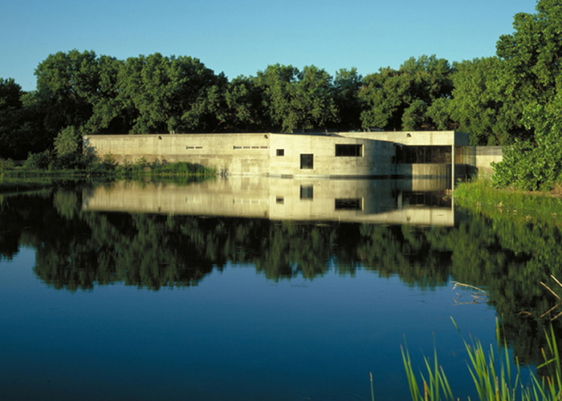

Rio Grande Nature Center