SCHOOL CASH INSTRUCTIONS

AISD has a safe and secure online system to collect money for students at Austin High. The system is referred to as: School Cash Online.

This system allows students to pay online for items such as dues, fees, and field trips using a Mastercard or VISA credit card. (FYI: a 3% merchant services fee is added to each credit card payment made.) Cash and checks are accepted only for families who do not have a way to pay online.

STEP 1:
To start using this system, go to this website to register: https://austinisd.schoolcashonline.com. Once there, click Get Started Today ​and follow the directions to set up an account that is tied to your credit card. For more information, click the “Support” link at the top of the page. The items on this page will answer most questions that you might have about School Cash Online.

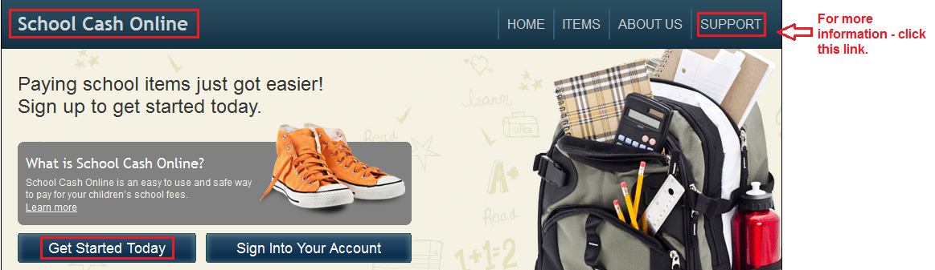

STEP 2:
Once your account is set up, you will have the opportunity to link it to a student. To do this you will need to provide the student’s ID #, last name, and date of birth. Once your account is linked to your student, you will be able to view and purchase all the items associated with them.

STEP 3:
Choose the item(s) you would like to purchase and complete transaction

